An Easier Can Opener

ME 100 Mechanical Engineering and Design Seminar
Fall 2021
Cameron Devine

Introduction
In the United States 54 million people have arthritis. This condition affects their ability to live normal daily lives due to reduced muscular strength in their hands. Due to this reduced strength, using a can opener can be a difficult task. To allow these individuals to live productive and normal lives, the standard can opener design can be modified to lessen the forces necessary for operation.

Existing Solutions
For those who have difficulty using a standard can opener, multiple solutions already exist. A relatively common device is the electric can opener, for which very little strength is required to operate. However, these devices are large, noisy, and require a power source which may not always be present. Can openers with an extra long crank also exist, but these devices would be difficult to operate when opening a shorter can, as is often used for tuna fish. The proposed can opener design will retain the compact form of a standard can opener, while reducing the operating forces to a similar degree as a model with a long handled crank.

Proposed Design
The proposed can opener design consists of a frame similar to a normal can opener, but modified so that the handle drives a small pinion which is meshed with a larger gear increasing the torque and decreasing the force required for operation. A sketch of the proposed design is shown in Fig. 1. This can opener is used in the same manner as a standard can opener, with the notable exception that the crank will have to be twisted in the opposite direction than normal.

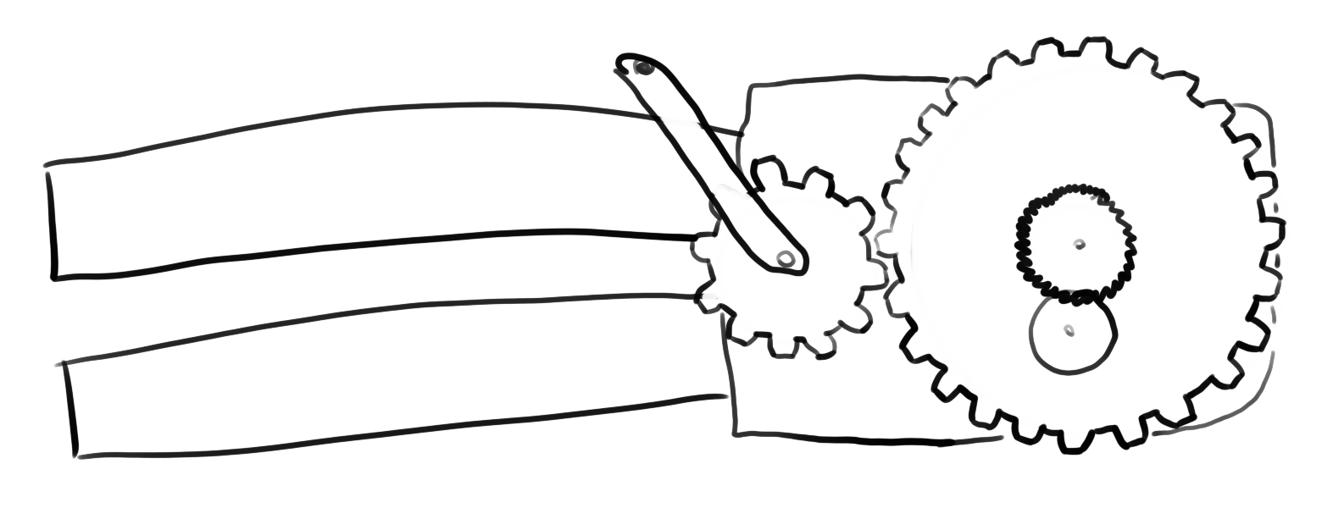Figure 1: The proposed can opener design utilizing gears to reduce the forces required for operation.

Design Review
Enived Noremac
Although the proposed design effectively reduces the forces needed to crank the can opener, this is only one of two places where force needs to be applied to a can opener to operate it. A significant amount of force is also required when the handle are squeezed together to initially pierce the top of the can. The forces to do this could be reduced by lengthening the handles.

Revised Design
<Describe your design changes along with an updated sketch. Discuss why you disregarded any review comments.>

